

Support Agreement - Standard

Contract Plan:
Agreement Term:
Prepared For:
Sales Agent:

Pricing & Details

IT Support Plan
Cyber Support Plan
User Count
Per User Rate | $
Starting Monthly Price | $ Paid Monthly
Starting Total Price | $ Paid in Full
Agreement Start Date
Agreement End Date
Billing Start Date
Payment Terms – Support Agreement
Payment Terms – Out of Scope
Payment Method | ACH (No Fees) Credit Card (3% Fee)
Principal Place of Support

Included Support Services
Cyber Support
Additional Support
IT Support
Cyber Support
Additional Support
IT Support

Internal Use Only

Additional Terms
Projects & Customer Requests

Our Help Desk at Your Fingertips

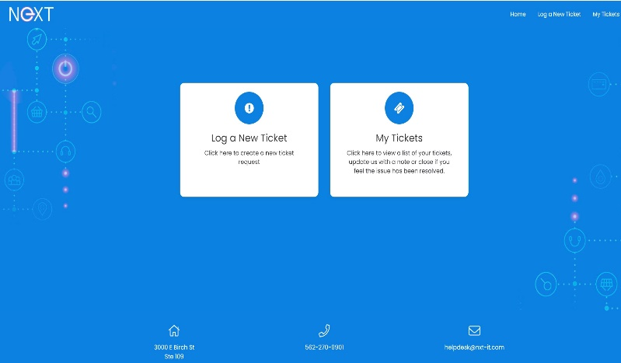
Go to help.nxt-it.com to access the ticket portal. Please bookmark this page in your browser for quick access in the future.
You can create, respond to, and manage tickets in this portal.

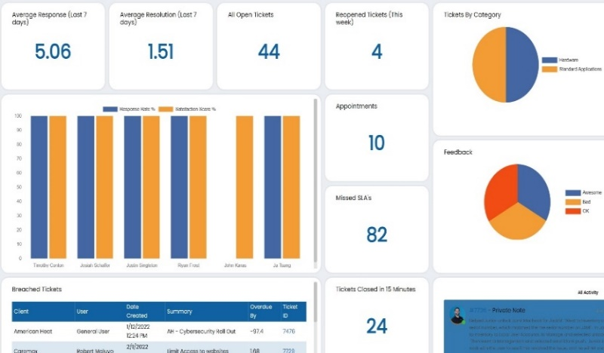

You may also e-mail us for help anytime by sending a request to helpdesk@nxt-it.com to initiate a ticket. Online portal access is recommended if you prefer to track the status of your ticket.

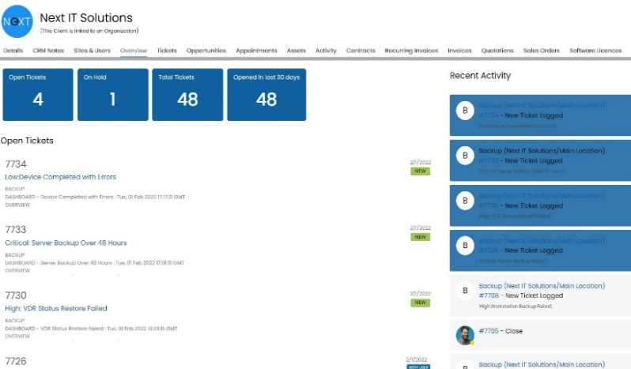
Feel free to contact the Help Desk directly by phone at 562-270-9901. Please keep in mind the best method of getting help is by creating a ticket mentioned in the steps above.
Regardless of how you decide to ask for assistance, we are always here to serve.

Standard operating hours are through from to . If you require after-hours support, please submit a ticket via the portal. Weekends and evenings are handled per ticket and scheduled at our discretion. We take your business hours seriously and make every decision to impact your operations as little as possible.

Service Level Agreement

Impact and Urgency
Our support system classifies tickets based on two key factors: Impact and Urgency. This approach ensures efficient prioritization of issues, facilitating timely and effective responses.

Impact
The extent to which an issue affects your business operations by the number of users impacted is categorized as follows, from least to most affected:
One User | The issue is limited to a single user.
Multiple Users | The issue affects more than one user but not everyone.
Everyone | The issue affects all users.

Urgency
Urgency indicates the speed at which an issue requires resolution, reflecting the customer's expectation for timely action:
Low | The issue can be addressed in a standard timeframe without immediate action.
Normal | The issue requires prompt resolution but is not critical.
High | The issue demands immediate attention to avoid significant disruption.

Priority Assignment Rules
Tickets are assigned a priority level based on the combination of Impact and Urgency, organized to ensure resources are allocated efficiently, and issues are resolved in an order that best supports business continuity:
 |  | Priority
 | One User | Multiple Users | Everyone
Low | Low | Low | Normal
Normal | Normal | Normal | High
High | Normal | High | Critical
SLA with Rapid Response |  |  |  | SLA without Rapid Response
Priority | Response Target | Resolution Target |  | Priority | Response Target | Resolution Target
Low | 4 Hours | 3 Days |  | Low | 8 Hours | 5 Days
Normal | 2 Hours | 4 Hours |  | Normal | 4 Hours | 8 Hours
High | 1 Hour | 2 Hours |  | High | 3 Hours | 6 Hours
Critical | 30 Minutes | 1 Hour |  | Critical | 2 Hours | 4 Hours

AGREEMENT TERMS
By ordering IT Support and/or Cyber Support Services from Upstream Tech, Inc. (NIT), you ("you" or "Customer") agree to the terms and conditions set forth herein.

1. SUBJECT OF THE AGREEMENT
The Agreement governs the provision of NIT's Maintenance Equipment / Software Service Contract products (the "Services") to the Customer by NIT and certain administration and servicing thereof. The Services comprise all parts and all normal labor for all hardware and software in the network.

2. SERVICES PROVIDED
NIT agrees to provide in-house, on-site, over-the-phone, and remote technical support for all hardware and software in the network for Customer's exclusive use for the "Agreement Term." Customer represents and warrants that Customer has or has access to the knowledge and expertise necessary to maintain, monitor, and secure the hardware in network.

3. FEES
Fees for the Services shall be charged per the schedule of payments on page two of this Agreement and are non-refundable unless decided otherwise at NIT's sole discretion.

4. PAYMENT
The Customer agrees to provide their preferred Payment Method of either Automated Clearing House (ACH) or Credit Card (CC) for NIT to retain on file and to make all monthly payments, whether via ACH or CC, exclusively through the NIT Billing Portal. No alternative payment methods will be accepted unless previously approved in writing by NIT.

4.1.
The Customer agrees to provide their preferred payment method, either Automated Clearing House (ACH) or Credit Card (CC), for NIT to retain on file for the payment of any purchases, projects, and out-of-scope work that the Customer has authorized. Furthermore, NIT only accepts ACH or credit card payments for recurring subscriptions, like Microsoft 365 licensing. At least one of these payment methods must be submitted and remain active. Paper checks are not accepted for recurring subscription costs.

4.2.
For product purchases through NIT, the Customer authorizes NIT to charge either the ACH or Credit Card on file for the quoted amount and any applicable fees upon approval.

4.3.
Refunds of Service fees will be made only for pre-payment of Service fees beyond the renewal date following the adequate notice and termination of this Agreement as provided for herein. Under no circumstances will there be a refund for the payment of this Contract. All charges for labor for add-ons of hardware and software to the network are non-refundable. NIT may grant refunds under any circumstances deemed appropriate without waiving any other rights hereunder.

4.4 CUSTOMER RESPONSIBILITY

Customer is responsible for monitoring its account status, billing, and contractual obligations and for providing timely written notice of any cancellation, non-renewal, or dispute. Failure to do so does not relieve Customer of its obligations under this Agreement.

5. TERM
Subject to termination in conformity with Section eleven of this Agreement, the initial term of this Agreement shall be for the "Agreement Term." NIT reserves the right to accept pre-payment of renewal periods and may, from time to time, offer financial incentives for such pre-payment. The Agreement Term, however, shall remain the full length of the "Agreement Term". To avoid a lapse in support, you will be informed of renewal 90 days before the "Agreement End Date." If an agreement is not reached 60 Days beyond the "Agreement End Date," NIT reserves the right to pause all licenses and services until resolved.

6. ADMINISTRATIVE ACCESS
Administrative access or "root" access to the hardware in the network is limited to you and your authorized agents. As a general rule, NIT has no access to the contents of your network. Nevertheless, NIT reserves the right to recommend, at its discretion, software and/or hardware upgrades to maintain the security and stability of the services provided and may recommend installing such upgrades. Standard fees for such upgrades shall be set by NIT and charged to the provided Payment Method on file upon approval by the Customer.

7. HARDWARE AND SOFTWARE PURCHASES
Throughout this "Agreement Length," when the Customer expresses interest in hardware or software purchases, NIT will provide recommendations and quotes. Should the Customer approve of the suggested purchase, they commit to procuring these items exclusively through NIT. Opting to purchase outside of NIT's recommendations may lead to unsupported network hardware and software devices, potentially incurring additional monthly charges.

8. HARDWARE, SOFTWARE & BACKUP
All Root Hardware and Software must use configurations conforming to NIT's requirements. Use of any software configuration may be declined at the sole discretion of NIT. The Customer understands that purchased hardware and software should comply with NIT specification or configuration requirements. The Customer can expect to receive support from NIT for the correction of errors caused by mistakes, faulty settings, and installation errors caused by the Customer. For Cloud Backup in N-Able Cove, Power users, operating on critical infrastructure, VIP workstations, or in C-Level or Upper Management roles, are granted unlimited backups for utmost data protection. Servers can access cloud backup up to a capacity of 10TB. Any data backup requirements exceeding this limit will incur additional charges at a rate of $0.20 per GB.
9. CUSTOMER CONDUCT

9.1.
NIT services and servers may only be used for lawful purposes. Any use which violates any City, State, Federal, or International Laws which may apply to NIT, Customer's local jurisdiction, or any jurisdiction that Customer or Customer's site may be subject to is strictly prohibited.

9.2.

While using NIT-supplied hardware, Customer will not post or transmit any unlawful, threatening, abusive, libelous, defamatory, obscene, offensive, indecent, pornographic, profane, or otherwise objectionable information of any kind, including without limitation any transmissions constituting or encouraging conduct that would constitute a criminal offense, give rise to civil liability, or otherwise violate any local, state, federal or international law, including without limitation the U.S. export control laws and regulations, and laws protecting intellectual property including copyright, trademark, trade secret, misappropriation, and anti-dilution laws.

10. INDEMNIFICATION

For purposes of this Section 10, NIT includes its parent company or companies, its subsidiaries, and affiliated companies.

10.1.
NIT shall indemnify and hold harmless the Customer, its officers, and employees from and against any and all damages, liabilities, losses, costs, and expenses (including reasonable attorney's fees) arising out of or relating to: (a) any breach by NIT of its obligations, representations, or warranties under this Agreement; (b) any infringement or misappropriation by NIT of any intellectual property rights of any third party in connection with the IT Services; (c) any violation by NIT of any applicable laws, regulations, or industry standards in connection with the IT Services; or (d) any negligence or willful misconduct by the NIT or its subcontractors in connection with the IT Services.

10.2.
The Customer shall indemnify and hold harmless NIT, its officers, and employees from and against any and all damages, liabilities, losses, costs, and expenses (including reasonable attorney's fees) arising out of or relating to: (a) any breach by the Customer of its obligations or representations, under this Agreement; (b) any use or modification by the Customer of the IT Services in a manner not authorized by this Agreement or by NIT ; (c) any violation by the Customer of any applicable laws, regulations, or industry standards in connection with the IT Services; or (d) any negligence or willful misconduct by the Customer or its employees in connection with the IT Services.

10.3.
Each party shall promptly notify the other party in writing of any claim for which it seeks indemnification under this clause. The indemnifying party shall have the right to assume and control the defense of such claim, at its own expense and with counsel of its choice, provided that such counsel is reasonably acceptable to the indemnified party. The indemnified party shall cooperate fully with the indemnifying party in such defense and shall not settle or compromise any such claim without the prior written consent of the indemnifying party, which consent shall not be unreasonably withheld or delayed.

10.4
INDEMNIFICATION FOR CUSTOMER CLAIMS

Customer shall indemnify and hold harmless Next IT from any costs, damages, or expenses arising out of claims initiated by Customer that are inconsistent with the express terms of this Agreement.

11. TERMINATION

NIT reserves the right to terminate this Contract depending upon the violation of any terms and conditions of this Agreement or at the sole discretion of NIT and will notify Customer and any third-party providers of services, merchandise, or information 14 days before termination.

NO WAIVER

Any failure or delay by Next IT to enforce any provision of this Agreement shall not constitute a waiver of that provision or any other provision. No course of dealing or prior accommodation shall modify this Agreement.

11.1.

NIT may deny Customer access to the hardware in the network with a 14-day notice if Customer engages in any conduct or activities that NIT, in its sole discretion, believes to violate any of the terms and conditions of this Agreement or in violation of any City, State, Federal or International Laws. NIT reserves the right to remove or remove access after notice of correction is given to any information or materials, in whole or in part, that, in its sole discretion, are unacceptable, offensive, in violation of this Agreement, or in violation of any City, State, Federal or International Laws.

12. RETURN OF HARDWARE
Upon termination of this Contract, all hardware shall remain the property of the Customer unless the hardware was leased to the Customer by NIT and will be returned to NIT within 30 days of the termination of this Contract.

13. SERVICE LEVEL AGREEMENT

13.1.
NIT makes every reasonable effort to maintain the uninterrupted operation of the NIT Services, subject to regularly scheduled network maintenance cycles; however, because many events and circumstances are beyond the control of NIT, NIT does not in any way warrant or otherwise guarantee the availability of the hardware in the network and is not responsible for any delay or loss of data, lack of connection, slow connection, or any other such issues unless it is due to the active negligence of NIT. Once the Customer notifies NIT of any issues, the issues will be resolved within the time stated above on page 5 of this Agreement. NIT may, at its sole discretion, limit or deny access to the network, if, in the judgment of NIT, such limitations or denials of access are required to assure the security of the network, the integrity of the network structure, or to prevent damage to the network, the software or the data stored on the NIT servers.

13.2.
All NIT Services are provided to you on an "As-Is" basis and without any warranty of any kind, whether expressed or implied, including, but without limitation, any implied merchantability or fitness for a particular purpose.

13.3.
The total sole and exclusive remedy available to you as the result of any breach of this Agreement, negligence, or any action or failure to act whether intentional or otherwise shall be limited to the total amount of service fees paid by you to NIT in the six (6) months immediately preceding any allegations of entitlement to such remedy, but in no event to exceed the total for this "Agreement Term" Agreement. NIT shall not be liable for any indirect, special, exemplary, punitive, incidental, or consequential damages, loss of profits, or loss of business due to any such action or inaction without regard to the likelihood of any such damages.

13.4.
NIT provides full technical support in accordance with the standard operating hours found on page four of this support agreement, with the exception of the following holidays unless otherwise stated in the additional terms and conditions found on page three of this Agreement:

- New Year's Day
- Memorial Day
- Independence Day
- Labor Day
- Thanksgiving Day
- Day After Thanksgiving
- Christmas Day

On these holidays, NIT will have limited availability for remote assistance only. This means response times may be longer than usual. Customers may have to wait until the following business day for on-site support for critical issues that cannot be resolved remotely.

13.5
SUSPENSION OF SERVICES

Next IT may suspend Services, in whole or in part, for nonpayment, breach, or operational risk without terminating this Agreement. Suspension shall not relieve Customer of its payment obligations.
14. SCOPE OF SUPPORT
An outline of the general Scope of Support Services provided by NIT, highlighting what is included ("In Scope") and excluded ("Out of Scope") for clear and transparent service delivery.

14.1. IT SUPPORT SERVICES
The specific IT Support Services available to the Customer can be found on Pages two and three of this Agreement. Still, as a complete list, NIT IT Support encompasses N-Central RMM, Unlimited Support, SentinelOne EDR, Live Help Desk, Vendor Liaison, Rapid Response, Virtual CIO, and Endpoint Backup.

14.1.1. UNLIMITED SUPPORT DEFINED
Unlimited Support is offered through NIT's IT Support Services. "Unlimited Support" provides no limit on Helpdesk Tickets that fall within the Scope of the offerings that range from "Routine Troubleshooting to Advanced Problem Solving," as further described below:

"Routine Troubleshooting" refers to the regular, day-to-day technical issues that are generally quick to identify and resolve.

"Advanced Problem Solving" involves more intricate and challenging IT issues that require in-depth analysis, expertise, and often more time to resolve, but not exceeding eight hours for one technician or six combined hours for two technicians in active work.

14.2. CYBER SUPPORT SERVICES
The specific Cyber Support Services available to the Customer can be found on Pages two and three of this Agreement. Still, as a complete list, NIT Cyber Support encompasses e-mail security, DNS web filtering, multi-factor authentication, dark web monitoring, defense training, password management, Microsoft 365 backup, and phishing simulations.

14.2.1. ADVANCED CYBER SUPPORT
- SIEM / SOC as a Service
- 24/7, 365 NOC as a Service with Remediation
- Vulnerability Scanning
- Black Box Pen Testing
- Grey Box Pen Testing
- Endpoint Backup Overage by GB ($0.20/GB)

14.3. OUT OF SCOPE
Any services outside of those listed explicitly on Pages two and three of this Agreement for your chosen Support package will be considered "Out of Scope." Any tickets, or thread of tickets aimed at resolving the same issue, that is estimated to take any singular Technician eight or more hours of active work, or two Technicians a combined total of six hours or more of active work, will be elevated to a "Project Opportunity." Examples of common "Project Opportunities" are as follows, but not limited to:

- Major Software Implementations or Upgrades
- Large-Scale Hardware Upgrades or Rollouts
- Custom Software Development
- Data Migration Projects
- Cybersecurity Audits and Remediation Projects
- Disaster Recovery and Business Continuity Planning
- Compliance and Regulatory Projects
- Network Redesign or Major Network Changes
- Employee Training and Education Programs
- Extensive System Integrations

Upon approval, charges for out-of-scope services and/or "Project Opportunities" will be billed to the ACH or Credit Card on file. Standard Project Labor hours are billed at $299.00/Hour, subject to change.

15. IDENTIFICATION INFORMATION

Legal guardian approval is mandatory for Minors who receive NIT services and software on their personal devices. However, this requirement is waived if a Minor uses only the Customer's devices for work-related tasks. Customer employees below 18 must provide their and their legal guardian's accurate contact details to NIT, and the Customer is responsible for updating this information as needed.

16. SECURITY

16.1.
The Customer retains full decision-making authority over their physical and digital security, including but not limited to Cloud, Infrastructure, Hardware, Software, Network, and Communications. NIT provides security recommendations, but the responsibility lies with the Customer to adopt or decline them. If the Customer diverges from NIT's advice, each shall assume their proportionate risks and liabilities for potential breaches or damages. While NIT will assist in addressing security issues promptly, it won't be held responsible for outcomes resulting from the Customer's security decisions.

16.2.
NIT and Customer agree that if security has been compromised in any way, each will notify the other immediately in writing as set forth in Section twenty herein. Each shall be held fully responsible for any misuse or compromise of Customer's network based on their involvement. The customer agrees that if any security violations are believed to have occurred in association with the Customer's network, NIT has the right to suspend access to the network pending an investigation and resolution. Customer also agrees that NIT has the right to cooperate in any government or legal investigation regarding any aspect of its services, including any networks used by Customer. Any use of the network to engage in software piracy or other violations of law will result in service suspension and be immediately reported to the appropriate authorities.

17. PRIOR AGREEMENTS
This Agreement supersedes any written, electronic, or oral communication Customer may have had with NIT or any agent or representative thereof and constitutes the complete and total Agreement between the parties.

A. NO EXIT OBLIGATION; DISCRETIONARY ACCOMMODATIONS

Customer acknowledges and agrees that Next IT has no obligation to offer, honor, or continue any “easy exit,” early termination accommodation, financing-based exit, payoff assistance, or similar arrangement, whether described verbally, in marketing materials, or in prior dealings.

Any decision by Next IT to permit an early exit, modify termination terms, or assist with third-party financing or vendor obligations is entirely discretionary, may be withdrawn at any time, and shall not be deemed a right, entitlement, or ongoing obligation.

Loss, change, or termination of any financing, lending, leasing, or third-party relationship shall not obligate Next IT to permit termination, modify this Agreement, or assume any related costs.

This Section supersedes any prior understanding or expectation regarding exit flexibility and shall govern notwithstanding any prior discussions or practices.
ENTIRE AGREEMENT; NO ORAL MODIFICATIONS

This Agreement constitutes the entire agreement between the parties and supersedes all prior or contemporaneous discussions, representations, proposals, or understandings, whether oral or written. No modification, waiver, or amendment shall be binding unless made in writing and executed by an authorized representative of Next IT.

18. JURISDICTION
This Agreement shall be interpreted under the laws of California without regard to any conflict of law
provisions.

19. DISPUTE RESOLUTION

DISPUTE RESOLUTION; FEE SHIFTING; WAIVER OF LITIGATION

(a) Mandatory Binding Arbitration.

Any claim, dispute, or controversy arising out of or relating to this Agreement, the Services, or the relationship between the parties (each, a “Dispute”) shall be resolved exclusively by final and binding arbitration administered by the American Arbitration Association (“AAA”) under its Commercial Arbitration Rules, as modified herein. The arbitration shall be conducted by a single arbitrator with substantial experience in information technology services and commercial contracts. The arbitration shall take place in Orange County, California, unless Next IT elects otherwise in writing.

(b) Waiver of Court Proceedings and Jury Trial.

To the maximum extent permitted by law, Customer knowingly and voluntarily waives any right to bring or participate in any lawsuit, jury trial, or court proceeding against Next IT arising out of or relating to this Agreement or the Services, except as may be required to enforce or confirm an arbitration award.

(c) Prevailing Party Attorneys’ Fees and Costs.

In any Dispute, arbitration, action to enforce an arbitration award, or related proceeding, Next IT shall be entitled to recover its reasonable attorneys’ fees, expert fees, arbitration fees, and costs from Customer to the fullest extent permitted by law if Next IT is the prevailing party. This provision shall apply regardless of whether such Dispute is brought in arbitration, court, or otherwise.

(d) Prohibition on Class and Representative Actions.

All Disputes must be brought on an individual basis only. Customer expressly waives any right to bring or participate in any class action, collective action, private attorney general action, or other representative proceeding against Next IT.

(e) Limitation of Remedies.

Customer agrees that its sole and exclusive remedies for any Dispute shall be limited to those expressly provided in this Agreement. In no event shall Customer be entitled to injunctive relief, equitable relief, or damages exceeding the limitations set forth herein.

(f) Governing Law.

This Agreement and any Dispute shall be governed by and construed in accordance with the laws of the State of California, without regard to conflict-of-laws principles, and the Federal Arbitration Act shall govern the interpretation and enforcement of this arbitration provision.

(g) Severability and Survival.

If any portion of this Section is found unenforceable, such portion shall be severed or modified to the minimum extent necessary to render it enforceable, and the remainder shall remain in full force and effect. This Section shall survive termination or expiration of the Agreement.

19.2 NO EQUITABLE RELIEF

Customer waives any right to injunctive or equitable relief and agrees that its sole remedies shall be those expressly provided in this Agreement.

20. NOTICE
Any notice under this Agreement shall be given by NIT to you via e-mail at the address provided by you to NIT at the commencement of this Agreement. Notice to the address provided is deemed sufficient regardless of your receipt of such e-mail.

21. NO AGENCY
Nothing contained herein shall be interpreted as creating an agency, partnership, or joint venture between NIT and the Customer.

22. AMENDMENT
AMENDMENT; CONTRACT VARIABILITY

Customer acknowledges and agrees that this Agreement is subject to amendment by Next IT from time to time. Next IT may amend, modify, or supplement this Agreement upon notice, which may be provided by posting the updated terms to Next IT’s applicable terms and conditions webpage or by other reasonable electronic notice.

Any such amendment shall become effective as of the date specified by Next IT and shall be binding on Customer upon Customer’s continued use of the Services, continued payment, or failure to object in writing within the time period specified in the notice, if any.

Customer further acknowledges and agrees that:
(a) this amendment right applies to this specific agreement and service arrangement;
(b) Next IT is not required to amend all customer agreements in the same manner or at the same time;
(c) Next IT may offer different terms, pricing, structures, or contractual language to other customers, whether existing or future;
(d) no amendment to this Agreement shall create any right to parity, most-favored-customer treatment, or uniformity across customers.

This Section shall apply notwithstanding any prior version of this Agreement and shall survive any modification, renewal, or continuation of Services.

23. SURVIVAL

All provisions which by their nature should survive termination or expiration shall survive, including but not limited to payment obligations, dispute resolution, limitations of liability, indemnification, and amendment rights.

24. AUTHORIZATION AND AGREEMENT

By signing below, I, the undersigned, represent and warrant that I am a duly authorized
representative of the Client with full power and authority to enter into this Agreement on behalf
of the Client. I further acknowledge that I have read and understood this Agreement in its entirety
and agree to be bound by its terms and conditions.

Business Name (Please Print)

Client’s Name (Please Print) Client’s Title

Email Phone Number

X
Client's Signature Date

